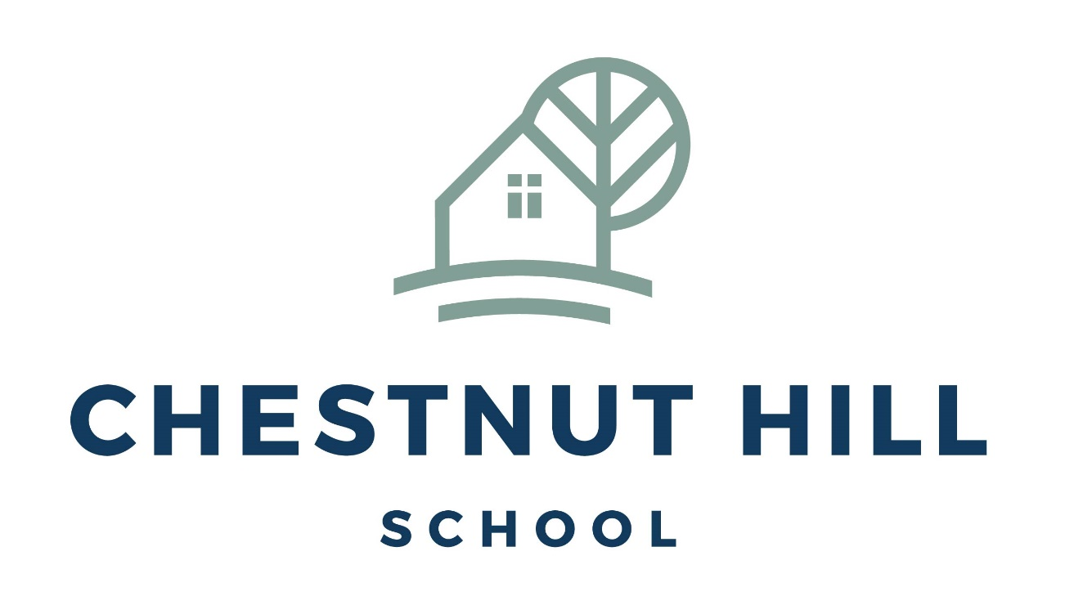

# Curriculum Policy Chestnut Hill School September 2024

**Approved by Vickie Salamone: Head of School**

# Last review: September 2024

# Next Review: Annually

**Curriculum Policy Chestnut Hill School September 2024**

In September 2023, as all schools in Wales, we implemented the New Curriculum for Wales. The world is changing, and we needed new ideas and creative use of technology; to address these challenges, the Welsh Government wanted to make sure that your child had the knowledge, skills and experiences they will need to make the most of their life.

Chestnut Hill is delivering a curriculum focused around the ‘four purposes of the curriculum’, to support your child, at their level. Our aspirations are for our learners to be:

* an ambitious, capable learner, ready to learn throughout their life
* an enterprising, creative contributor, ready to play a full part in life and work, if they are able to
* an ethical informed citizen, ready to take part in Wales and the world and
* a healthy confident individual, ready to live a fulfilling life as a valued member of society.

Our curriculum focuses on the six key areas of learning:

* Humanities
* Expressive arts
* Mathematics
* Science and Technology
* Health and Well-being
* Language, Literacy and communication

Embedded in this framework will also be:

* human rights
* diversity and respecting differences
* experiences and skills for careers and the workplace
* learning about local, national and international contexts
* developmentally appropriate relationships and sexuality education.

**In Expressive Arts**, your child will explore art, dance, drama, film and digital media and music to develop their creative, artistic and performance skills.

**In Humanities** they’ll learn about the world, society and events in the past and present.

They’ll explore the challenges and opportunities that face us, and what ethical action we can take to safeguard the world and its people in the future.

**In Mathematics and Numeracy**, your child will develop their understanding of numbers and use symbols in maths. They’ll explore shapes and measurement and learn about statistics and probability.

**Health and Well-being** is about looking after their physical and mental health including emotional well-being. They’ll learn about healthy eating and how to make good decisions, deal with influences and develop healthy relationships.

**In Languages, Literacy and Communication**, your child will learn about languages. They’ll understand and use Welsh, English and other languages. They’ll study and create literature, and communicate in spoken, written or visual ways. This could include poetry, drama and film.

**In Science and Technology** your child will learn about biology, chemistry, physics, computer science and design and technology. They’ll learn about design and engineering, living things, matter, forces and energy, and how computers work.

There is a teacher and other key staff members leading each of these teams.

# Principles

Our curriculum embraces the progression steps outlined for Wales for our children who are operating at a National Curriculum level but prior to this our curriculum is divided into 5 key aspects of learning, with evidence taken from the ‘Routemap’ for children with significant learning needs.

This begins with objectives taken from child development.

The first step is exploration: this allows children to engage with their environment and begin to respond to stimuli.

The next step is realisation: this allows children to opportunities to explore their stimuli and begin to realise what things may do.

The third step is anticipation: where children are able to know what is going to happen and a cause-and-effect relationship.

The fourth step is persistence: where children are enjoying an activity and are persistent in going back to repeat it and realise it is the same (object permanence may begin to appear here).

The final step is initiation: where children understand that some strategies will achieve the desired results that they want.

There will be times when children fit neatly into one of these boxes but there may also be some children who have a ‘spiky profile’ and are much more accomplished in some areas than others. Each child is unique and therefore each child’s experiences in school will be different. Children will be grouped in classrooms where similar experiences are required.

Almost all of the pre-National Curriculum steps will be play-based and experiential. Children learn best through a hands-on play-based approach.

* Play allows learning to be fun and stimulating.
* Play develops skills and concepts.
* Play helps to develop communication skills.
* Play helps to develop positive attitudes.
* Play helps to develop independence.
* Play is about children learning through perseverance, concentration and attention to detail

– characteristics usually associated with work.

* Play is not only crucial to how children become self-aware and the way in which they learn the rules of social behaviour; it is also fundamental to intellectual development.
* Play is a child’s way of learning about their world and processing events in their life.

Many aspects of play will involve the outside learning and as such some of our classrooms will operate ‘free-flow’ provision to ensure opportunities inside and outside reflect each other.

There will be some children who are approaching the end of the provision in school where a more bespoke curriculum is required to ensure that we are providing them with the best opportunities. This may be with a more focused work-experience framework or a curriculum that allows them space to build relationships in their own time.

There will also be opportunities for formal learning, for some of our children, where a more traditional timetable is followed; however, this too will need to be flexible to meet the needs of our pupils’ emotional well-being. There will be links established with a local secondary school to allow our students to sit GCSEs as external candidates in line with the Welsh Curriculum.

Once our children begin operating in a progress step 4 curriculum the subjects and schemes of work will be further divided into specific strands. This will allow for children to reach their potential and maybe an opportunity for more of them to do subject specific GCSEs as children may be able to flourish in art or music or computer science, for example.

# Organisation and planning

We plan our curriculum in three phases and organise teaching and learning in the way that best meets the needs and interests of our pupils.

# Long Term Plans

There is a long term grid with rationale and then a 6 year topic plan to incorporate all 6

aspects of the curriculum; with a clear focus. The premise is that each topic is covered in depth during a week to ensure that there is consistency and opportunities for over-learning. Many aspects of language and communication will remain ongoing throughout the term, as these are key skills required at all times. Some children will also be able to manage a more

structured timetable that allows for the teaching of maths and English daily. There are schemes of work for all subject.

# Medium Term Plans

Are formulated as grids with a primary objective for each phase of learning. Cross- curriculum links are exploited and many aspects of social. Moral and cultural values, regarding date specific events; especially those relevant to Wales. Links are made with food

technology, care and visits to the community. Key literacy texts are identified to enhance the curriculum and can be a focus for the whole term, especially as children become more familiar with them and are able to recognise and join in with rhyme and repetition.

# Short term plans

These are written by the teacher and link directly to the child and their needs. They also incorporate IEP targets to ensure all aspects of their needs are met. These can be informal and annotated in a format that works for the teacher. The only criteria is that another

member of the team must be able to follow them.

# Clinical support

Many of our children will require therapy of some description, this will include occupational therapy, speech and language therapy and psychotherapy, amongst other things. These

sessions are timetabled and delivered by the on-site team of clinicians. There is also ongoing training for all school staff from the team to ensure we are able to deliver many aspects of the therapy they require. Therapy works best when it is delivered little and often with many of our children; however, there are clearly times when children require direct 1:1 therapy input. There are dedicated training sessions three times a week for staff to attend; some of these training sessions will be bespoke to a particular child and others will be generic.